Logistic Regression

* Regression models a target prediction value based on independent variables. It is mostly used for finding out the relationship between variables and forecasting.
* Different regression models differ based on — the kind of relationship between dependent and independent variables, they are considering and the number of independent variables being used.
* Logistic regression is used when the output are in categorical form.
* The major objective of Logistic Function:

For this project, logistic regression is being for the categorizing the data and to predict the probability of rainfall.

Major formulae used in the project:

The fundamental equation of generalized linear model is:

g (E(y)) = θ0+x1θ1+x2θ2+x3θ3+x4θ4+x5θ5+··· (1)

Where

g () is the function of the link, E(y) is the linear predictor i.e. minimum and maximum temperature, relative humidity and wind speed.

The role of link function is to link the expectation of y to linear predictor. The cost function is use to predict the optimum value of θ0, θ1, θ2, θ3, θ4, θ5.

For those values cost function has minimum value and the predicted line is best fit

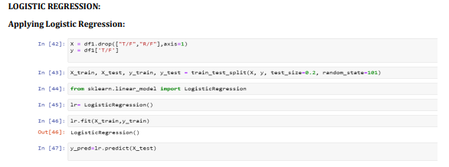

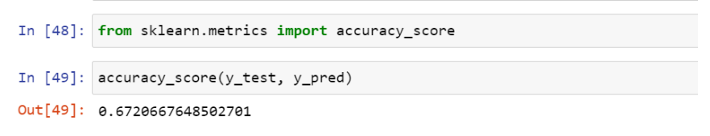

Output 1: logistic Regression

Done by Mrunali Madarkar